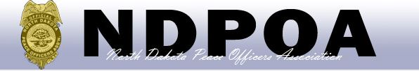
108th Annual Conference
August 13th – 16th, 2019
Canad Inn
1000 South 42nd Street
Grand Forks, North Dakota 58201

SHOOTING EVENTS
REGISTATION FORM

Tuesday, August 13 & Wednesday, August 14, 2019
8:00 am – 5:00 pm (CST); 8:00 am – 3:00 pm (CST)

Grand Forks Sheriff’s Office Range
13839 262nd Street Southeast Grand Forks, North Dakota
Grand Forks Police Department Range
Public Safety Center 1220 South 52nd Street Grand Forks, North Dakota

NDPOA Course (include 2/4 man team) $40.00 $______
Off Duty Hand Gun $10.00 $______
Individual 4 gun match $15.00 $______
Individual Sniper Course $15.00 $______
Individual Carbine Course $15.00 $______
Team Tactical match $45.00/ team $______
Governor’s Twenty (no prior shoots in year) $25.00/ 3 shoots $______
Governor’s Twenty $6.00/ shoot $______
Fun Shoot $10.00/ shoot $______

Shooter's Name: _____________________________________________________
Department: ________________________________________________________
Two man team member's 1. _________________________________________
2. _________________________________________
Four man team member's 1. _________________________________________
2. _________________________________________
3. _________________________________________
4. _________________________________________

Teams may be made up at the conference the day of the shoot, if needed. See shooting rules on the NDPOA webpage.

Pre-registration is due by July 25, 2019
Mail entry and fees to (Check payable to NDPOA):

North Dakota Bureau of Criminal Investigation
Attn: NDPOA 2019 Committee
PO Box 5983
Grand Forks, North Dakota 58206-5983

