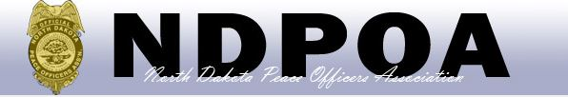
108th Annual Conference
August 13th – 16th, 2019
Canad Inn
1000 South 42nd Street
Grand Forks, North Dakota 58201

NDPOA K9 Challenge
REGISTRATION FORM

Tuesday, August 13, 2019

9:00 am-Registration
9:30 am-Rules Meeting
9:45 am-Competition Begins

This year’s conference K9 competition will be a narcotics only event. You must be current in your NDPOA dues to participate. This will be a FUN and STRESS FREE EVENT and is an opportunity to attend and have a friendly competition with handlers from across the state.

Contact Lt. Adam Dvorak at the North Dakota Highway Patrol with any questions you may have:
ajdvorak@nd.gov

Handler Name _________________________________________ K9 ____________________
Agency___________________________ Phone Number:______________________
$20 Fee Enclosed: Yes_______ No_______

Pre-registration due by July 25, 2017
Mail entry and fees to (Check payable to NDPOA)

North Dakota Bureau of Criminal Investigation
Attn: NDPOA 2019 Committee
PO Box 5983
Grand Forks, North Dakota 58206-5983

